INTERNSHIP REPORT – TASK 3
Title: Protein Structure Prediction and Visualization
Name: [Navya Thalathoti]
Internship: CodeAlpha
Course / Department: [Bioinformatics] B.TECH
Gmail:navyathalathoti@gmail.com

1.Objective
To predict the three-dimensional (3D) structure of a selected protein from UniProt using SWISS-MODEL or AlphaFold DB, visualize it in PyMOL, and analyze its structural features.

2. Protein Details
Feature | Details
Protein Name | Insulin
UniProt ID | P02144
Organism | Homo sapiens
3. Methods
3.1 Sequence Retrieval
- Retrieved protein sequence in FASTA format from UniProt.
- Saved as insulin.fasta.
- Sequence:
>sp|P01308|INS_HUMAN Insulin OS=Homo sapiens OX=9606 GN=INS PE=1 SV=1
MALWMRLLPLLALLALWGPDPAAAFVNQHLCGSHLVEALYLVCGERGFFYTPKTRREAED
LQVGQVELGGGPGAGSLQPLALEGSLQKRGIVEQCCTSICSLYQLENYCN

- 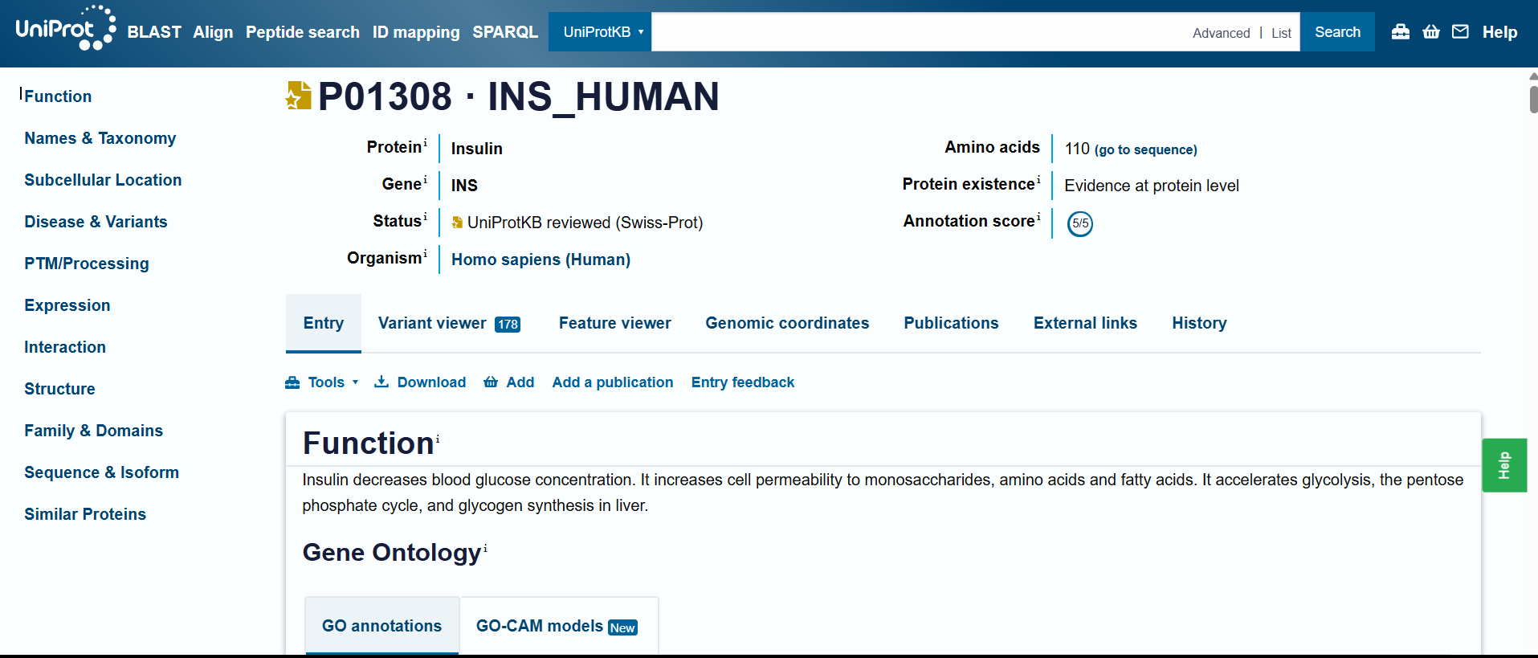

3.2 Structure Prediction
- Predicted 3D structure using SWISS-MODEL / AlphaFold DB.
- Downloaded the predicted PDB file.
- 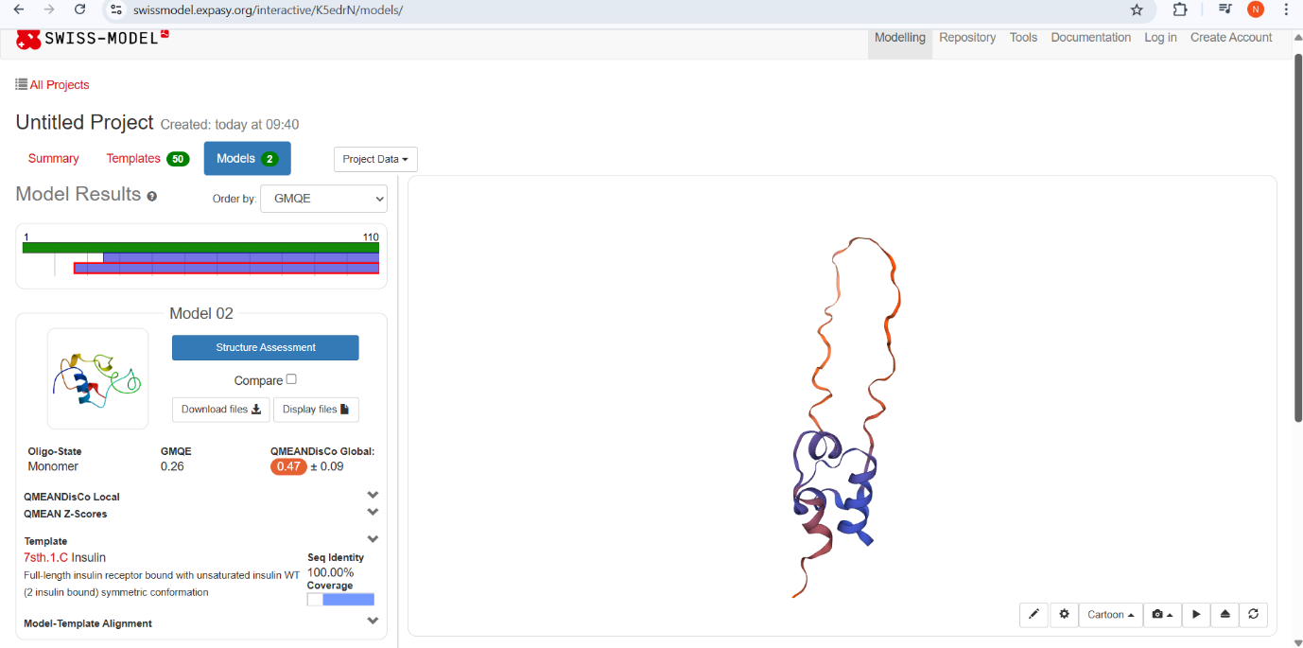
3.3 Visualization in PyMOL
- Opened PDB file in PyMOL.
- Commands used:
show cartoon
color cyan, all
zoom all
turn x, 90
png insulin_structure.png, dpi=300
- Visualized the protein from different angles, including surface and cartoon views.
- 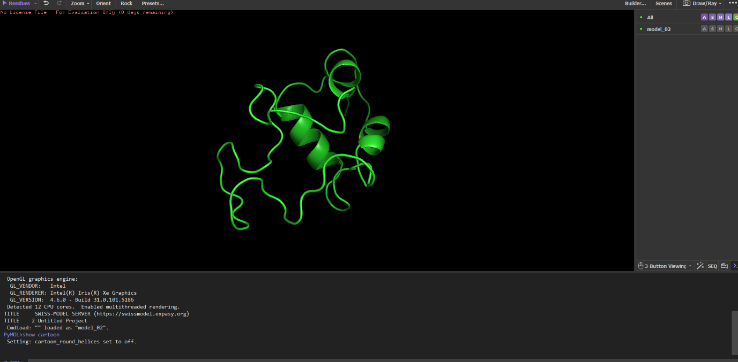
- 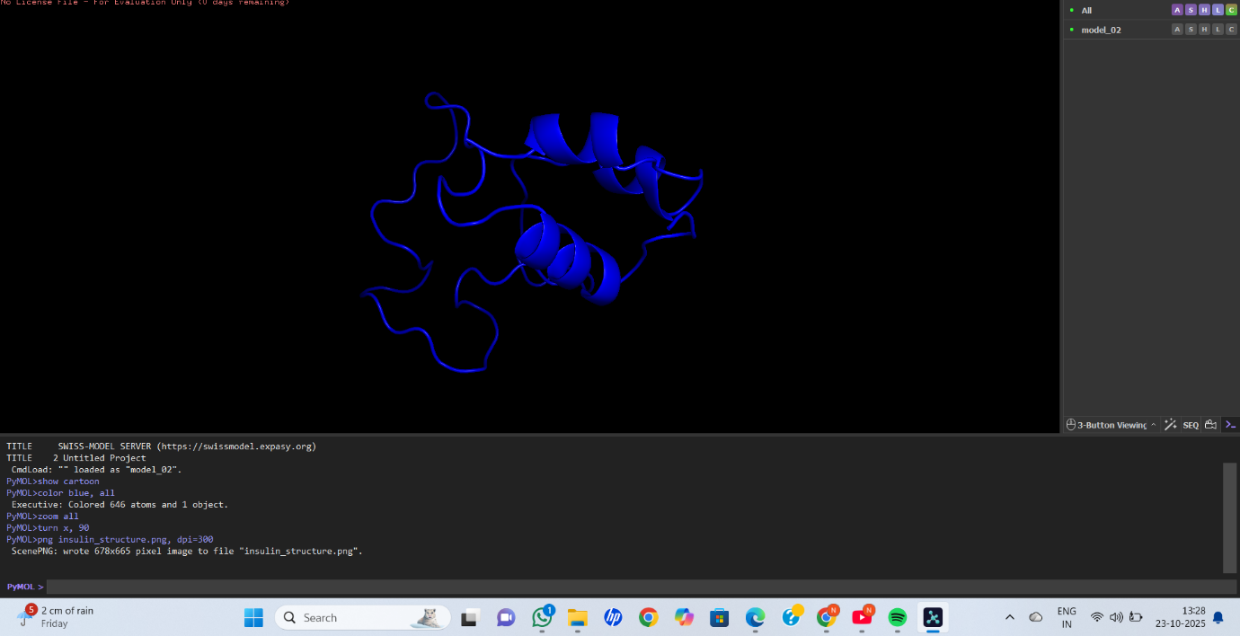
- 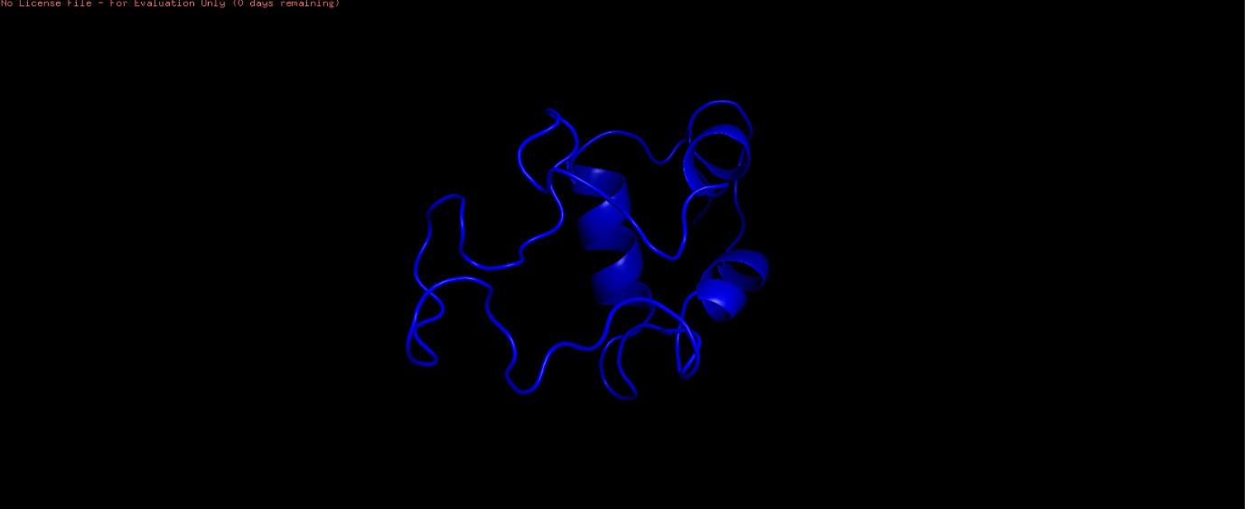

4. Results / Observations
- Structure shows α-helices and loops, typical for insulin.
- Surface view highlights regions accessible to solvent.
- Predicted model confirms the compact folding necessary for biological function.

5. Structural Features
Feature | Observation
Secondary structure | α-helices and loops
Active site / functional region | Residues forming disulfide bonds (Cys7–Cys19, Cys20–Cys31)
Shape | Globular compact
Stability | Structure confirmed by PyMOL visualization

6. Conclusion
The 3D structure of insulin was successfully predicted and visualized.
The PyMOL images clearly show secondary structure elements, active regions, and overall fold, which helps in understanding protein function.

